Sentimental analysis for marketing

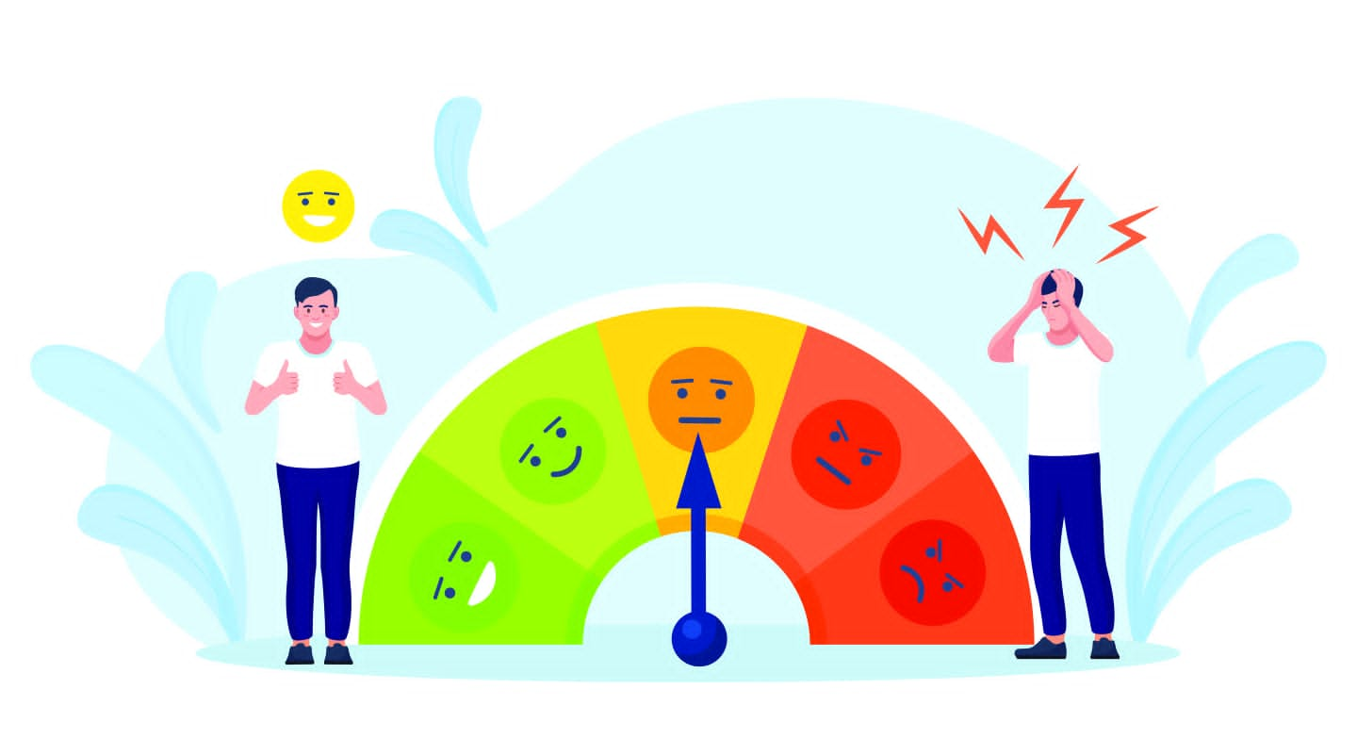

# **Development ideas for sentimental analysis for marketing**

# For development ideas, consider features like sentiment trend analysis over time, sentimental analysis for customer reviews,sentiment-based recommendations, or sentiment-based alerts for extreme reviews. Your source code may vary depending on the technologies and tools you choose, but the core sentiment analysis logic will remain similar.

**Here's I choose sentimental analysis for customer reviews**

# Sentiment Analysis for Customer Reviews:

Develop a system that automatically analyzes and categorizes customer reviews on e-commerce platforms. This can provide valuable insights into product strengths and weaknesses.

## Purpose of sentimental analysis for customer reviews

Sentiment analysis for customer reviews involves analyzing text data to determine the sentiment or emotional tone expressed in the reviews.

**Outline of the development process**

1. **Data Collection**

* **Obtain customer reviews from your data source. You can use web scraping, APIs, or pre-existing datasets.**

1. **Preprocessing**

* **Prepare the data by cleaning and tokenizing the text. This may involve removing special characters, punctuation, and stopwords.**

**Python**

**Import nltk**

**From nltk.corpus import stopwords**

**From textblob import TextBlob**

**Nltk.download(‘stopwords’)**

**Stop_words =set(stopwords.words(‘english’))**

**Def clean_text(text):**

**Text = text.lower()**

**Words = text.split()**

**Words = [word for word in words if word not in stop_words]**

**Return ‘ ‘.join(words)**

1. **Sentiment Analysis**

* **Use sentiment analysis libraries like TextBlob to determine sentiment polarity.**

**python**

**Def analyze_sentiment(text):**

**Analysis = TextBlob(text)**

**If analysis.sentiment.polarity > 0:**

**Return ‘Positive’**

**Elif analysis.sentiment.polarity == 0:**

**Return ‘Neutral’**

**Else:**

**Return ‘Negative’**

1. **Visualization**

* **Visualize the sentiment distribution using libraries like Matplotlib or Seaborn.**

1. **Integration**

* **Integrate the sentiment analysis into your application, whether it's a website, app, or any other platform.**

1. **Continuous Improvement**

* **Collect feedback and continuously refine your sentiment analysis model.**

**Sentiment analysis for customer reviews is a natural language processing (NLP) technique that aims to determine the emotional tone or sentiment expressed in a text-based customer review. It involves analyzing the text to classify it as positive, negative, or neutral, and sometimes providing a sentiment score to quantify the sentiment strength. This analysis helps businesses and organizations understand how their customers feel about their products or services, allowing them to gain insights into customer satisfaction, identify areas for improvement, and make data-driven decisions based on customer feedback.**

**simple example of Python code for sentiment analysis of customer reviews**

**python**

**Import nltk**

**From nltk.sentiment import SentimentIntensityAnalyzer**

**# Download VADER lexicon (if not already downloaded)**

**Nltk.download(‘vader_lexicon’)**

**# Initialize the Sentiment Intensity Analyzer**

**Sia = SentimentIntensityAnalyzer()**

**# Sample customer reviews**

**Reviews = [ “This product is amazing!”,**

**“I had a terrible experience with this company.”,**

**“The service was mediocre.”,**

**“I love this product!”,]**

**# Analyze the sentiment of each review**

**For review in reviews:**

**Sentiment = sia.polarity_scores(review)**

**Compound_score = sentiment[‘compound’]**

**If compound_score >= 0.05:**

**Print(f”Positive: {review}”)**

**Elif compound_score <= -0.05:**

**Print(f”Negative: {review}”)**

**Else:**

**Print(f”Neutral: {review}”)**

**key tools and libraries:**

**1.Python**

**Python is the primary language for most sentiment analysis projects due to its extensive support for natural language processing (NLP) libraries and data analysis tools.**

**2. Natural Language Processing (NLP) Libraries**

**NLTK (Natural Language Toolkit)**

**NLTK provides tools for working with human language data and is often used for basic sentiment analysis.**

**spaCy:**

**spaCy is a fast and efficient NLP library with pre-trained models for various NLP tasks.**

**TextBlob**

**TextBlob is a simple library for processing textual data and provides a straightforward API for sentiment analysis.**

**3. Machine Learning Frameworks**

**scikit-learn**

**scikit-learn is a versatile machine learning library in Python that can be used for sentiment analysis when combined with feature engineering techniques.**

**TensorFlow and PyTorch**

**These deep learning frameworks are suitable for building and training custom sentiment analysis models using neural networks.**

**4. Hugging Face Transformers**

**The Hugging Face Transformers library provides pre-trained transformer models fine-tuned for a wide range of NLP tasks, including sentiment analysis. You can use models like BERT, RoBERTa, or DistilBERT for highly accurate sentiment analysis.**

**5. VADER Sentiment Analysis**

**VADER (Valence Aware Dictionary and sEntiment Reasoner) is a lexicon and rule-based sentiment analysis tool that’s available through the NLTK library.**

**6. Data Collection and Storage Tools**

**Pandas**

**Pandas is used for data manipulation and analysis, including loading customer reviews from various sources (e.g., CSV files, databases) and storing results.**

**SQL Databases**

**Use databases like MySQL, PostgreSQL, or SQLite to store and manage customer reviews data.**

**7. Visualization Tools**

**Matplotlib and Seaborn**

**These Python libraries are helpful for creating data visualizations and plots to represent sentiment analysis results.**

**Tableau or Power BI**

**For more advanced and interactive data visualization and reporting.**

1. **Web Frameworks (Optional)**

**If you plan to create a web-based application, consider web frameworks like Flask or Django for building a user interface to interact with your sentiment analysis tool.**

1. **Cloud Services (Optional)**

**Cloud services like Amazon Comprehend, Google Cloud Natural Language, or Azure Text Analytics offer APIs for sentiment analysis, making it easier to integrate into project.**

**10. Text Preprocessing Tools**

**Beautiful Soup If you’re working with web data, Beautiful Soup can be used for web scraping.**

**Gensim**

**Useful for text preprocessing and topic modeling.**

**11. Jupyter Notebooks**

**Jupyter notebooks are a great environment for developing and documenting your sentiment analysis project interactively.**

**12. GitHub**

**Use version control with platforms like GitHub to collaborate, share, and manage your code.**

**13. Text Data Sources**

**Data sources such as online review datasets, social media data, and customer feedback surveys can be used to collect customer reviews.**

**Sentiment analysis of customer reviews offers several benefits:**

**1.Customer Insights: It helps businesses understand how customers feel about their products or services, providing valuable feedback.**

**2.Product Improvement: Identifying negative sentiments allows companies to make improvements and enhance customer satisfaction.**

**3.Competitive Analysis: It helps benchmark products or services against competitors by comparing sentiment scores.**

**4.Marketing and Branding: Positive sentiment can be leveraged in marketing and branding efforts to build a positive image.**

**5.Real-time Feedback: Offers real-time insights, enabling rapid response to customer issues or concerns.**

**6.Customer Engagement: Allows companies to engage with customers by responding to reviews and concerns**

**7.Trend Analysis: Helps identify trends and patterns in customer feedback, enabling strategic decision-making.**

**8.Predictive Analytics: Sentiment analysis can inform future product development and marketing strategies.**

**CONCLUSION :**

**Overall, sentiment analysis is a valuable tool for improving customer satisfaction and business performance.**

